Chapter 8 Practice Tizzy Quest SCORE ___________

1. For what value(s) of x is the expression $\frac{x^{2}- 9}{2x^{2}- 3x - 9}$ undefined?

Simplify each expression.
2. $\frac{x^{3}}{x^{2} - 64}$ ÷ $\frac{x^{3}}{x + 8}$

3. $\frac{3b^{2} + 3b - 6}{b^{2} - 6b + 5} ∙ \frac{b^{2} - 25}{6b + 12}$

4. $\frac{\frac{3m^{2} - 75}{6m^{2} + 30m}}{\frac{4m - 20}{9m^{2} + 45m}}$

5. $\frac{2}{x - 2}$ – $\frac{8}{x^{2} - 4}$

6. $\frac{5}{3m - 1}$ – $\frac{2}{1 - 3m}$

Find the LCM of each set of polynomials.
7. 4$m^{3}$p, 9m$p^{4}$, 18$m^{4}p^{2}$

8. $n^{2}$ – 2n – 8, $n^{2}$ + 2n – 24

For Questions 9 and 10, determine the equations of any vertical asymptotes and the values of x for any points of discontinuity in the graph of each rational function.
9. f(x) = $\frac{x + 1}{x - 3}$

10. f(x) = $\frac{x^{2} - 2x - 8}{x + 2}$

11. Graph f(x) = $\frac{x + 3}{\left(x – 2\right)(x+1)}$

12. If y varies jointly as x and z and y = 6 when x = 4 and z = 12, find y when
x = 24 and z = 5.
1. _______________________

2. _______________________

3. _______________________

4. _______________________

5. _______________________

6. _______________________

7. _______________________

8. _______________________

9. _______________________

10. _______________________

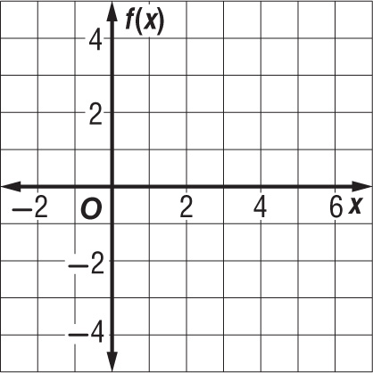
11.

12. _______________________

Chapter 8 Tizzy Quest (continued)

13. PHOTOGRAPHS A film-developing company noted that in a particular town the number of customers requesting online delivery of their vacation pictures varied directly with the number of households having high-speed Internet access. Currently, 5000 households in the town have high-speed Internet access and 80 customers request online delivery of their photographs. If this trend continues, how many customers should the film-developing company expect to request online delivery when 12,000 households have high-speed Internet access?

14. If y varies inversely as x and y = 25 when x = 6, find y when x = 150.

15. GASES The volume V of a gas varies inversely as its pressure P. If V = 80 cubic centimeters when P = 2000 millimeters of mercury, find V when P = 320 millimeters of mercury.

For Questions 16 and 17, state whether each equation represents a direct, joint, inverse, or combined variation.

16. $\frac{n}{10q}$ = r, with dependent variable r

17. $\frac{m}{7n}$ = 1, with dependent variable n

For Questions 18 and 19, solve each equation or inequality.

18. x + $\frac{2x}{x - 2}$ = $\frac{3x - 2}{x - 2}$

19. 9 + $\frac{2}{m}$ > $\frac{47}{m}$

20. PAINTING Alice can paint a room in 8 hours. Her assistant can paint the same room in 12 hours. How long will it take if the two of them work together?

Bonus Solve $\frac{\frac{1}{x + 2} + \frac{1}{x - 3}}{\frac{1}{x +2} - \frac{1}{x - 3}}$ = 1.

13. _______________________

14. _______________________

15. _______________________

16. _______________________

17. _______________________

18. _______________________

19. _______________________

20. _______________________

B: _______________________

