Chapter 7 Mid-Chapter Practice Test SCORE _____________
(Lessons 7-1 through 7-4)

Part I Write the letter for the correct answer in the blank at the right of each question.

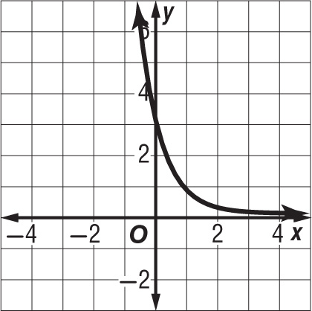
1. Find the domain and range of the function shown.

2. Solve $4^{2x}$ = $8^{x + 4}$.

3. Write the equation $4^{3}$ = 64 in logarithmic form.

4. Evaluate $\log_{4}{32}$.

5. Solve $\log_{3}\left(7x-3\right)$ ≥ $\log_{3}\left(5x\right)$.

6. Write the equation $5^{4}$ = 625 in logarithmic form.

7. Write the equation $\log_{7}{49}$ = 2 in exponential form.

8. Solve $\log_{5}\left(2x-1\right)$ > $\log_{5}\left(4x\right)$.

Part II

9. Write an exponential function whose graph passes through (0, –5) and (–2, –20).

10. Write $\log_{\frac{1}{3}}{p}$ = –3 in exponential form.

1. ________________

2. ________________

3. ________________

4. ________________

5. ________________

6. ________________

7. ________________

8. ________________

9. ________________

10. ________________

