Chapter 4 Mid-Chapter Practice Test SCORE _____________
(Lessons 4-1 through 4-4)

Part I Write the letter for the correct answer in the blank at the right of each question.

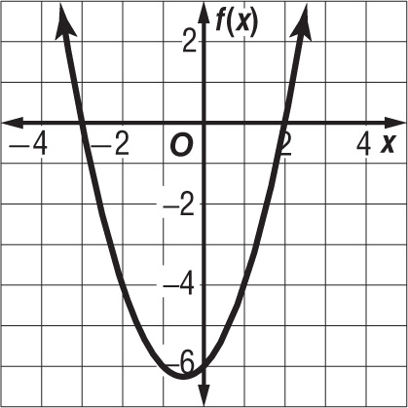
1. Which function is graphed?
A f(x) = $x^{2}$ – x – 6
B f(x) = $x^{2}$ + 5x – 6
C f(x) = $x^{2}$ + x – 6
D f(x) = ${(x-2)}^{2}$

2. By the Zero Product Property, if (3x – 1)(x + 5) = 0, then .

3. Write a quadratic equation with 7 and $-\frac{5}{2}$ as its roots. Write the equation in the form a$x^{2}$ + bx + c = 0, where a, b, and c are integers.

4. The current in one part of a series circuit is 3 – 2j amps. The current in another part of the circuit is 3 - 6j amps. Find the total amps in the circuit.

5. Solve $x^{2}$ + 5x = –5. If exact roots cannot be found, state the consecutive integers between which the roots are located.
A –2, –3 C between –4 and –3; between –2 and –1
B –3 D between –5 and –4; between –2 and –1

Part II

6. Solve $x^{2}$ – 4x + 3 = 0 by graphing.

7. Determine whether f(x) = $-{\frac{1}{2}x}^{2}$–4 x – 9 has a maximum or a minimum value and find that value.

For Questions 8 and 9, solve each equation by factoring.

8. $x^{2}$ – 3x = 40 9. 3$x^{2}$ = -x

10. Simplify $\frac{4i}{2+ 2i}$.

1.________________________

2. ________________________

3. ________________________

4. ________________________

5. ________________________

6. ________________________
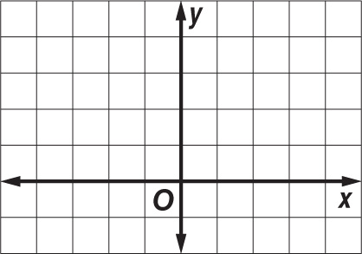

7. ________________________

8. ________________________

9. ________________________

10._______________________

