Chapter 8 Mid-Chapter Practice Test SCORE _____________
(Lessons 8-1 through 8-3)

Part I Write the letter for the correct answer in the blank at the right of each question.

1. For what value(s) of x is the expression $\frac{x(x - 5)}{(x + 2)(x^{2} - 16)}$ undefined?

For Questions 2-5, simplify each expression.

2. $\frac{4y^{2} - 1}{3y - 1} ∙ \frac{1 - 3y }{2y+ 1}$

3. $\frac{x^{2} - 6x + 8}{3x - 12}$ ÷ $\frac{x^{2} - 4 }{x^{2} + 5x + 6}$

4. $\frac{\frac{4m^{2} - 36}{6m^{2} + 18 }}{\frac{2m - 6}{3m^{2} + 9}}$

5. $\frac{1}{6}$ – $\frac{5}{15w}$ + $\frac{3}{10w}$

Part II
6. Simplify $\frac{x}{x^{2} + 5x+ 6}$ – $\frac{1}{x^{2}+ x-6}$.

For Questions 7 and 8, find the LCM for each set of polynomials.

7. 12$a^{2}$, 15$b^{3}$, 20a$b^{2}$ 8. 5$x^{2}$ – 20, 3x + 6

9. Determine the equations of any asymptotes in the graph of f(x) = $\frac{x^{2} + 4x }{ x^{2} + 4x - 12}$

10. Graph f(x) = $\frac{-2}{x + 4}$.

1. ________________

2. ________________

3. ________________

4. ________________

5. ________________

6. ________________

7. ________________

8. ________________

9. ________________

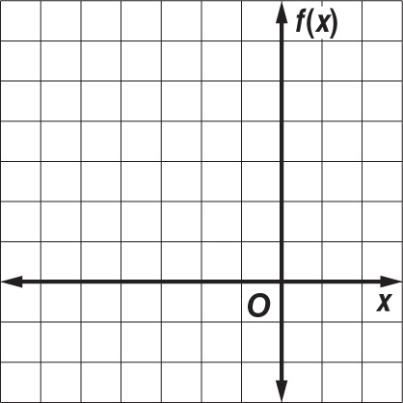
10.

