7-3 Practice
Logarithms and Logarithmic Functions

Write each equation in exponential form.

1. $\log_{6}$ 216 = 3 2. $\log_{2}$ 64 = 6 3. $\log_{3}$ $\frac{1}{81}$ = –4

4. $\log_{10}$ 0.00001 = –5 5. $\log_{25}$ 5 = $\frac{1}{2}$ 6. $\log_{32}$ 8 = $\frac{3}{5}$

Write each equation in logarithmic form.

7. $5^{3}$ = 125 8. $7^{0}$ = 1 9. $3^{4}$ = 81

10. $3^{-4}$ = $\frac{1}{81}$ 11. ${\left(\frac{1}{4}\right)}^{3}$ = $\frac{1}{64}$ 12. ${7776}^{\frac{1}{5}}$ = 6

Evaluate each expression.

13. $\log_{3}$ 81 14. $\log_{10}$ 0.0001 15. $\log_{2}$ $\frac{1}{16}$ 16. $\log_{\frac{1}{3}}$ 27

17. $\log_{9}$ 1 18. $\log_{8}$ 4 19. $\log_{7}$ $\frac{1}{49}$ 20. $\log_{6}$ $6^{4}$

Graph each function.

21. f(x) = $\log_{2}$ (x – 2) 22. f(x) = –2 $\log_{4}$ x

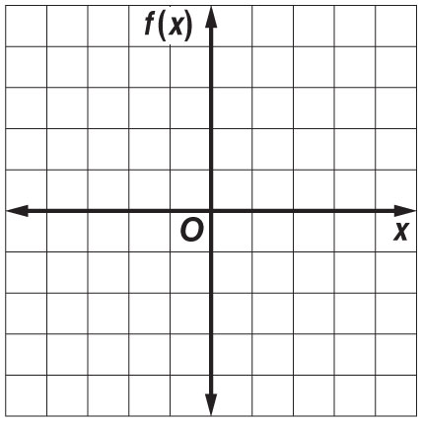

23. SOUND An equation for loudness, in decibels, is L = 10 $\log_{10}$ R, where R is the relative intensity of the sound. Sounds that reach levels of 120 decibels or more are painful to humans. What is the relative intensity of 120 decibels?

24. INVESTING Maria invests $1000 in a savings account that pays 4% interest compounded annually. The value of the account A at the end of five years can be determined from the equation $\log_{10}$ A = $\log_{10}$ [1000${(1 + 0.04)}^{5}$]. Write this equation in exponential form.
7-3 Word Problem Practice
Logarithms and Logarithmic Functions

1. CHEMISTRY The pH of a solution is found by the formula pH = – log H, where H stands for the hydrogen ion concentration in the formula. What is the pH of a solution to the nearest hundredth when
H is 1356?

2. FIND THE ERROR Michio wanted to find the value of x in the equation ${2(3)}^{x}$ = 34. He first converted the equation to $\log_{3}$ 2x = 17. Next he wrote 2x = $3^{17}$ and used a calculator to find x = 64,570,081. Was his answer correct? If not, what was his mistake and what is the right answer?

3. SOUND The decibel level L of a sound is determined by the formula L = 10 $\log_{10}$ $\frac{I}{M}$. Find I in terms of M for a noise with a decibel level of 120.
4. EARTHQUAKES The intensity of an earthquake can be measured on the Richter scale using the formula
y = ${10}^{R - 1}$, where y is the absolute intensity of the earthquake and R is its Richter scale measurement.

Richter Scale Number | Absolute Intensity
1 | 1
2 | 10
3 | 100
4 | 1000
5 | 10,000

An earthquake in San Francisco in 1906 had an absolute intensity of 6,000,000. What was that earthquake’s measurement on the Richter scale?

5. GAMES Julio and Natalia decided to play a game in which they each selected a logarithmic function and compare their functions to see which gave larger values. Julio selected the function f (x) = 10 $\log_{2}$ x and Natalia selected the function 2 $\log_{10}$ x.

a. Which of the functions has a larger value when
x = 7?

b. Which of their functions has a larger value when
x = 1?

c. Do you think the base or the multiplier is more important in determining the value of a logarithmic function?

